**CSE3501- Information security analysis and audit**

**Lab Assignment 3**

**Reg.No:19BCE2555**

**ALOKAM NIKHITHA**

**Rainbow Cracking:**

RainbowCrack is a computer program which generates rainbow tables to be used in password cracking. RainbowCrack differs from "conventional" brute force crackers in that it uses large pre-computed tables called rainbow tables to reduce the length of time needed to crack a password drastically. Rainbow tables are tables of reversed hashes used to crack password hashes. Computer systems requiring passwords typically store the passwords as a hash value of the user's password. When a computer user enters a password, the system hashes the password and compares it to the stored hash

**Password Cracking:**

Here I have demonstrated on how to decrypt the hash codes of different words.

Here We are actually decoding the hash which actually has

(“i am girl”)

Generate the hashes of the words to be decrypted.

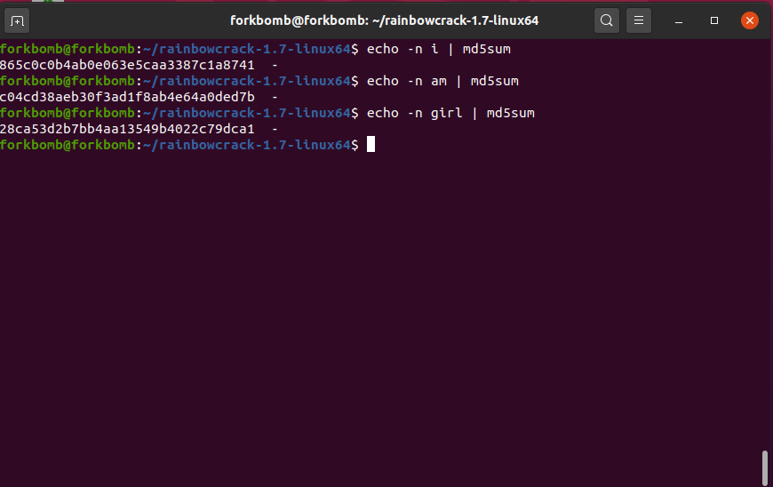

**Navigating to root directory.**

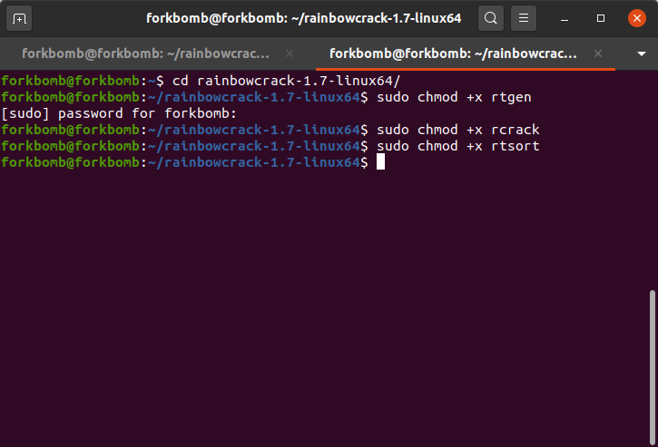

**Creating rainbow table**

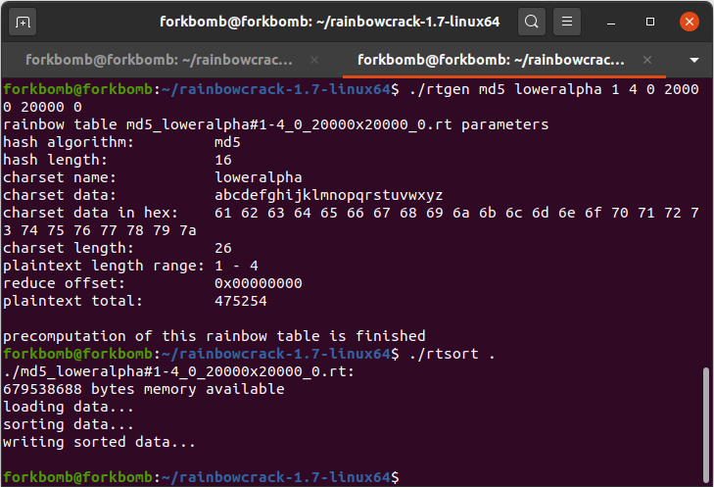

**Decrypting words.**

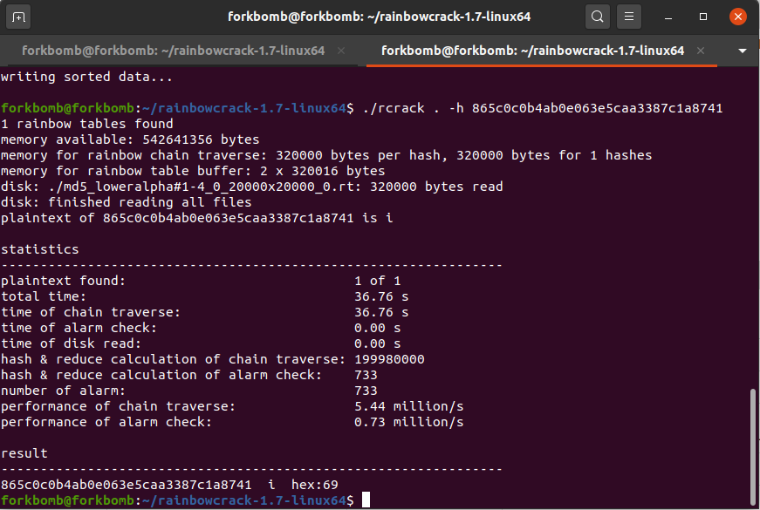

**The Decrypted word is “i”**

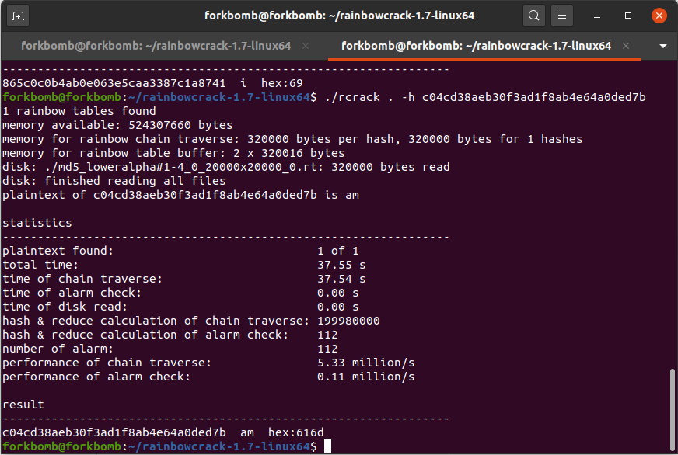

**The Decrypted word is “am”**

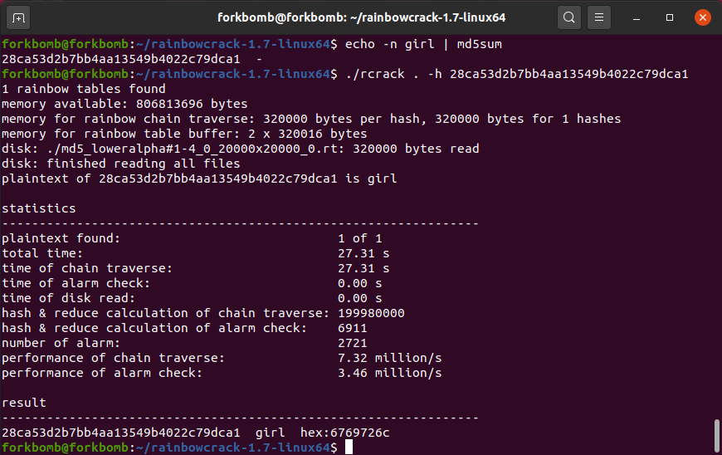

**The Decrypted word is “girl”**